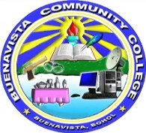

|  |  |
| --- | --- |
| **BUENAVISTA COMMUNITY COLLEGE**  *Cangawa, Buenavista, Bohol* | |
| **Subject Title:** Physical Education 2 | **Chapter** 4 |
| **Topic:** Philippine Folk dance/Traditional Dance | **Teacher:** Ms. Ma. Lobelia E. Infanso, LPT |

**Learning Objectives**

At the end of this chapter learners are expected to:

1. discuss the concept behind the Philippine Folk Dance,
2. identify the importance of Philippine Folk Dance and;
3. demonstrate dance forms relating to Philippine Folk Dance

**Lesson Proper:**

**Introduction**

Rites and dances are still being performed to this day because they serve as the beliefs and social systems of the ethnic Filipinos. If life is deemed hard, these rites and dances give expression and solace to their needs and sometimes give them courage and determination. These rites and dances are revivified by action and movements, and by the motives and spirits that inspire or require them.

Countries in the world have their own cultures made more colorful, beautiful and vibrant because of Folk Dances. These dances are a reflection of who they are. In the west the Americans have their “Square Dance”. In the east, the Chinese have their symbolic “Dragon Dance”, the Japanese have the ancestral dance “Bon Odori”. The Philippines on the other hand, boasts of a variety of Filipino Folk Dances.

**What is Folk Dance?**

* traditional dances of countries which were evolved naturally and spontaneously in connection with everyday activities and experiences of the people who developed them.
* the oldest form of dance and the earliest form of communication.
* Folk dance is the heartbeat of the people.
* traditional social expressions of the ideals, mores, feelings and thoughts of a people or group of people through body movement.
* it is the outburst of people’s feeling.

**Objectives of the Philippine Folk Dances**

1. To foster patriotism and nationalism through the study of our dances.
2. To arouse better appreciation of the Philippine music and folk dances.
3. To provide, through dancing, a healthful form of relaxation and recreation.
4. To develop a graceful and rhythmic coordination of body movements that will improve posture.
5. To preserve the posterity, folk dance and music indigenous to the different regions of the Philippines.
6. To demonstrate the growth of Filipino culture through the evolution of the Philippine dances.

**5 Major Classifications of Philippine Folk Dances**

1. **Cordillera Dances**

The mountainous Central Cordillera region of Northern Luzon is also known by the term “Philippine Skyland”. Inhabiting this rugged terrain are six ethno-linguistic tribes known as the *Ibaloy, Kankanay, Ifugao, Kalinga, Apayao* and *Bontoc.* They prefer to be called by their respective tribal names rather than the collective term Igorot, which was first used by the Spaniards and later by Christian lowlanders. These tribes were generally unfazed by Spanish colonization. This homogeneous group is recognized by their common socio-cultural traits. They hold common religious beliefs, generally nature-related, and make propitiatory offerings to *anitos*, or household gods. Among these people of the Cordillera, dance continues to be an expression of community life that animates the various rituals and ceremonies. It serves for self-edification of the performers and entertainment for the spectators. They dance to appease their ancestors and gods to cure ailments, to insure successful war-mating activities or to ward off bad luck or natural calamities. They dance to congregate and socialize, for general welfare and recreation, and as an outlet for repressed feeling. They also dance to insure bountiful harvests, favorable weather, and to mark milestones in the cycle of life.

Examples:

**UYA-UY**

* This is an Ifugao wedding festival dance accompanied by gongs and is performed by the affluent to attain the second level of the wealthy class. Wealthy people who have performed this dance are entitled to the use of gongs at their death.

**PATTONG**

* *Pattong* is also known as the “Bontoc War Dance” connectively as in the early times, *pattong* is part of the headhunting and war ceremonials inciting feelings of strength and courage as the warriors prepare to stalk their enemy.

**BANGA**

* This dance is performed with Kalinga women showing their agility in balancing the *bangas* on top of their heads while toddling through rice paddies and mountain paths; a daily routine to fetch water from the mountain springs.

1. **Spanish Influenced Dances / Maria Clara Dance**

In 1521, Ferdinand Magellan came to the archipelago, signaling the start of Spanish colonization. However, the Spanish didn't get a foothold in the Philippines until 1565. Three centuries of Spanish rule left an imprint on the Filipinos. Many of them were converted to Catholicism and forced to take Spanish surnames. During this period, Western culture spread through the islands, including such Western dances as the waltz, fandango and polka. With a little Filipino flare, they quickly became part of the culture. This "new” style of dance was named *Maria Clara* after the tragic character in Jose Rizal's novel *"Noli Me Tangere”.*

Example:

**LA JOTA MONCADENA**

* + Is one of the most famous interpretation and adaptation of the *Aragonese Jota dance*. People of Moncada, Tarlac, call it rather by a different name: *Jota Florana*. The *Jota Florana* was danced to the Ilocano/Yogad bamboo musical instrument ensemble called *tallelet*.

**MAZURKA BOHOLANA**

* + this tradional bottom dance was popular in Bohol and in other provinces during the Spanish time. This was originally performed with couples scattered informally about the room with no definite sequence of steps and direction followed.

**POLKA SA NAYON**

* + this ballroom polka was popular in the province of Batangas during the Spanish time. It was usually danced during town fiestas and in big social affairs.

1. **Muslim Dances**

Mindanao, the Philippines’ southernmost island, is the country’s cultural melting pot. It houses influences from Spain, China, Indonesia, and the Middle East. Although Mindanao carries a strong flavor from other lands, there are people who have lived there before it became a breeding ground of foreign trade. Tribes such as the *T’boli, Bilaan, Manobo, Bagobo,* and other groups inhabit the vast regions of Mindanao. Like their Northern Luzon counterparts, these groups honor their gods for the fruits and trials of daily life. What distinguishes them from other tribes in the Philippines is their intricate craftsmanship in metal, clothing, and jewelry. These tribes pride themselves in their concept of beauty and are known for creating colorful sets of jewelry and clothing out of dyed pineapple and banana fibers with are showcased in their traditional dances. The Muslims in the Philippines, also known as *Moros*, were able to resist Spanish conquest. They preserved the Islamic lifestyle that differs from the majority of the Philippine population. The dances are characterized by vivid colors and rhythmic movements which reflect the influence of Arabian and Indo-Malaysian cultures.

Example:

**SINGKIL**

* Singkil originated from the Maranao people who inhabit the shores of Lake Lanao. It is a re-telling of an episode from the Maranao epic legend *Darangen* involving the rescue of Princess Gandingan (abducted by the *diwatas*) by the legendary Prince Bantugan.

**PANGALAY**

* This dance is a courtship dance from the Tausug tribe. It is believed that the women of the Tausug tribe can only wear the “janggay,” or brass fingernails, after they have visited Mecca. Thus, their hands can never be used for any household work.

**VINTA/MANGALAY**

* *“Vinta”* refers to the boat; Royal figures balance atop the bamboo poles, which portray the movement of the *vinta* across the Sulu Sea. This dance portrays the Philippine Muslims’ deep relationship with the sea.

1. **Tribal Dances**

Tribes such as the *T'boli, Bilaan, Manobo, Bagobo*, and other groups inhabit the vast regions of Mindanao. Like their Northern Luzon counterparts, these groups honor pagan gods for the fruits and trials of daily life. What distinguishes them from other tribes in the Philippines is their intricate craftsmanship in metal, clothing, and jewelry. These tribes pride themselves in their concept of beauty and are known for creating colorful sets of jewelry and clothing out of dyed pineapple and banana fibers with are showcased in their traditional dances.

Example:

**PAGDIWATA**

* A crystallized presentation of an ancient nine-day ritual of thanksgiving among the *Tagbanuas* of Palawan for a rice harvest focused on the *babaylan* or priestess and her ministrations.

**KADAL TAHAW**

* A tribal dance performed by T’boli tribe, this dance mimics the hopping and flying behaviour of the *Tahaw* bird and is performed to celebrate good harvest.

**BINAYLAN-BANOG**

* Higaonon and Agusanon Manobo tribal dance that depicts the movement of a hen, her *banog* (baby chicks) and a hawk that lurks to find her prey. The tribe kills the sacred and powerful hawk which tried to capture one of the chicks.

1. **Rural Dances**

Perhaps the best known and closest to the Filipino heart are the dances from the rural Christian lowlands: a country blessed with so much beauty. To the Filipinos, these dances illustrate the fiesta spirit and demonstrate a love of life. They express a joy in work, a love for music, and pleasure in the simplicities of life. Typical attire in the Rural Suite includes the colorful *balintawak* and *patadyong* skirts for the women, and *camisa de chino* and colored trousers for the men.

Example:

**BINASUAN**

* Is a folk dance that originated in Bayambang, Pangasinan,. The word “*binasuan*” means “with the use of drinking glasses.” The dancers balance glasses on their heads and in their hands as they move. The glasses are filled with rice wine, which makes any misstep a messy mistake. People dance *binasuan* at weddings and festivals. A group of dancers generally performs *binasuan*, moving in unison, but occasionally breaking into smaller groups and performing different choreography.

**TINIKLING**

* considered the national folkdance. Originated from Leyte Province, this dance is in fact a mimic movement of “tikling birds” hopping over trees, grass stems or over bamboo traps set by farmers. Dancers perform this dance with remarkable grace.

**MAGLALATIK**

* this dance was created to represent a fight between the Moros and the Christian community over *latik*, a product obtained after the coconut milk has been boiled. Furthermore, this dance is performed during festive occasions such as feasts and religious processions.

**5 Fundamental Positions of Arms and Feet**

**1st Position**

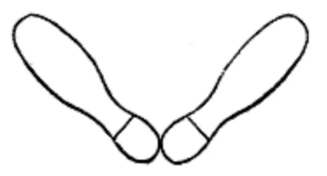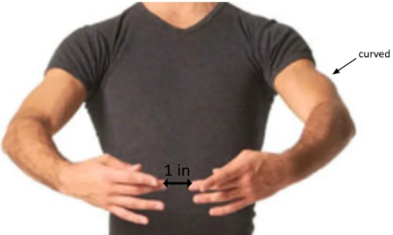**Arms**: Bend both arms at chest level. Elbow rounded, fingers slightly pointing downward.

**Feet**: Form a V-shape with your feet by bringing your heels together to touch while keeping your toes away from each other.

**2nd Position**

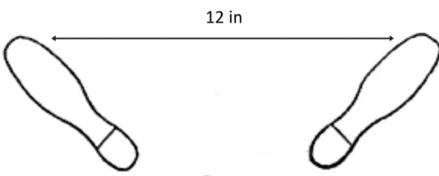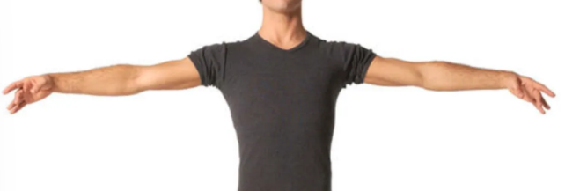**Arms**: Open both arms sideward, elbows rounded fingers slightly pointing downward.

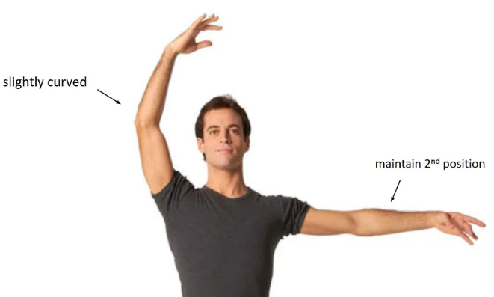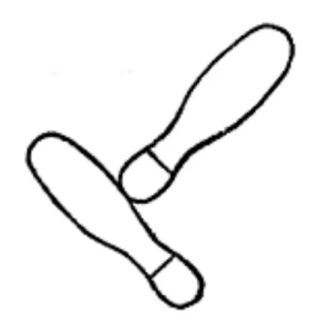**Feet**: Move one foot sideward. Your feet should be parallel to each other while maintaining a distance of about 12 inches.

**3rd Position**

**Arms**: Place the right arms sideward. Elbow slightly bend.

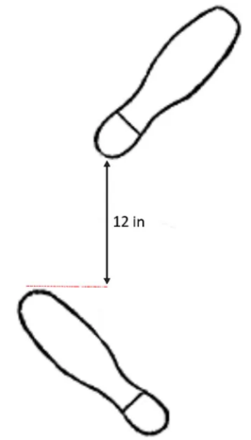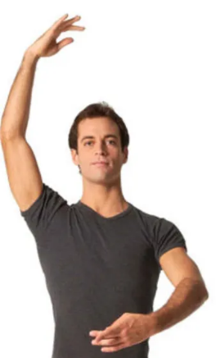**Feet**: Bring your foot’s heel to touch the arch of your other foot, with both feet turned outward.

**4th Position**

**Arms**: Raise the left arm upward, right arm in front.

**Feet**: Put your foot forward while the other foot still retains its position. The distance between the two feet should be about 12 inches.

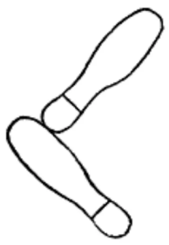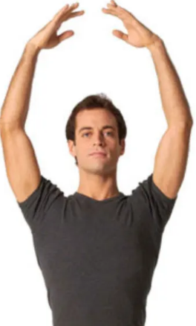**5th Position**

**Arms**: Raise both arms upward. Elbows rounded.

**Feet**: Bring the heel of the foot in front to touch the toe of the other. Both feet should still be pointing outward.

**ACTIVITY:**

In a one whole sheet of yellow pad answer the following questions.

1. In your barangay, what might be the common Philippine Folk Dance that they perform especially during occasions?
2. What can you say about our Philippine Folk Dance?
3. To our younger generation, which do you prefer to teach them, Philippine folk dance or Contemporary dance? Explain your answer.

**ASSIGNMENT:**

1. Study this module for next meeting we will have a quiz.
2. Practice the Fundamental Position of Both Arms and Feet because by next meeting we will have a demonstration with regards to this topic.